Christopher Horyczun
March 4th 2026
Cs 2020 (Friday)
Introduction to Statistics for Data Analytics
Exam 1

Question 1:
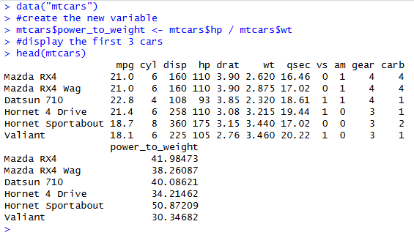
- I created a new variable called power_to_weight by dividing the horsepower (hp) by the weight (wt) of the car. This gives a ratio that shows how much power the car has compared to its weight, which is useful for comparing performance between vehicles. After creating the variable, I used head(mtcars) to display the first six rows of the dataset to make sure the new column was added correctly. From the output we can see the power_to_weight column appears in the dataset with calculated values for each car.
- I filtered the mtcars dataset to only include cars that have 6 cylinders and a fuel efficiency greater than 20 mpg. I used logical conditions to check both requirements at the same time. After filtering the dataset, I printed the results to see which cars met the criteria. Finally, I used nrow() to count how many cars matched the conditions, which came out to 3 cars in total. This shows that only a small number of vehicles in the dataset have both moderate engine size and relatively good fuel efficiency.
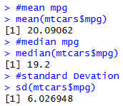
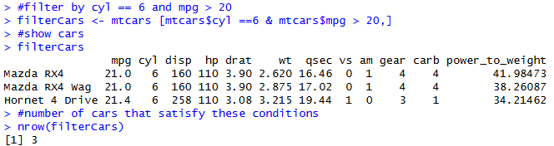
- I calculated some basic descriptive statistics for the mpg variable in the dataset. The mean mpg is about 20.09, which represents the average fuel efficiency across all cars in the dataset. The median mpg is 19.2, which means half of the cars get less than this value and half get more. The standard deviation is about 6.03, which shows that the mpg values vary quite a bit between vehicles. Overall, this tells us that fuel efficiency is fairly spread out in the dataset, with some cars being much more efficient than others.
- I created a scatterplot comparing car weight (wt) and fuel efficiency (mpg). Each point represents a car in the dataset. After plotting the points, I created a linear regression model and added the regression line using abline(). The plot shows a clear negative relationship between weight and mpg, meaning that as the weight of the car increases, fuel efficiency generally decreases. This makes sense because heavier cars usually require more energy to move, which leads to lower miles per gallon.
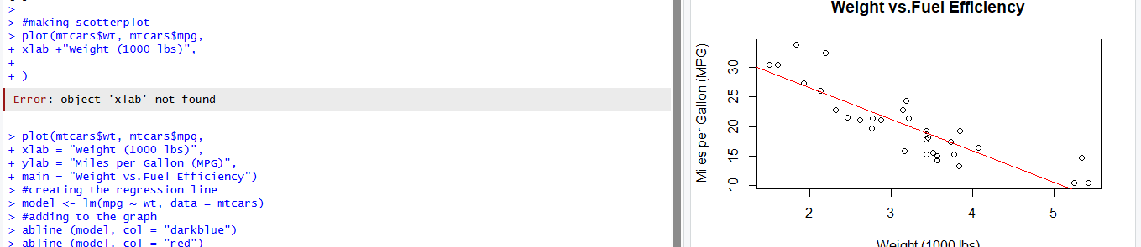

Question 2:
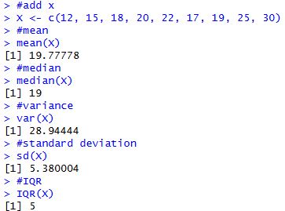
- I created a vector called X that contains the given data values. Then I used built-in R functions to calculate the mean, median, variance, standard deviation, and interquartile range. The mean value of the dataset is about 19.78, while the median is 19, which are very close to each other. This suggests the data is fairly balanced around the center. The standard deviation of about 5.47 shows that the values have a moderate amount of spread around the mean. The IQR of 7 indicates the middle 50% of the data falls within a range of 7 units.
- I created two visualizations of the dataset: a histogram and a boxplot. The histogram shows how frequently values appear across the range of the data. The boxplot summarizes the distribution by showing the median, quartiles, and overall spread. These plots make it easier to visually understand the distribution of the dataset compared to just looking at the numbers. Using visualizations like these is helpful in data analysis because it quickly shows patterns and possible outliers.
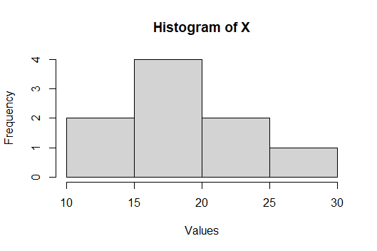 | 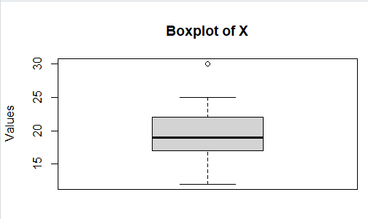
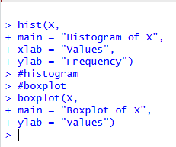

- Looking at the histogram and boxplot, the distribution of the data appears to be slightly right-skewed because the larger values like 25 and 30 extend the right side of the distribution. Most of the values are clustered between about 15 and 22, which is where the center of the data lies. The boxplot does not show any clear outliers, since all values fall within a reasonable range of the rest of the dataset. The spread of the data is moderate, since the values range from 12 to 30, but most of them are still fairly close to the mean around 20. Overall, the dataset shows some variation but is still fairly concentrated around the middle values.

Question 3:
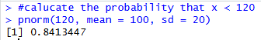
- I used the pnorm() function to calculate the probability that the random variable is less than 120. Since the distribution has a mean of 100 and a standard deviation of 20, the value 120 is one standard deviation above the mean. The result of about 0.8413 means there is roughly an 84% chance that a randomly selected value from this distribution will be less than 120. This also means that most values in this distribution fall below 120.
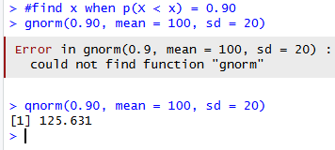
- I used the qnorm() function to find the value of x where 90% of the distribution falls below it. Since the normal distribution has a mean of 100 and a standard deviation of 20, the result is about 125.63. This means that 90% of the values from this distribution are expected to be less than about 125.63. In other words, this value represents the 90th percentile of the distribution.
- I used the rnorm() function to generate 200 random values from a normal distribution with a mean of 100 and a standard deviation of 20. I then created a histogram to visualize the distribution of the simulated data. The probability = TRUE option allows the histogram to be scaled so a probability density curve can be added. After that, I overlaid the theoretical normal curve using curve(dnorm()). The histogram should look roughly bell-shaped and line up fairly closely with the red curve, which shows that the simulated data follows the expected normal distribution.
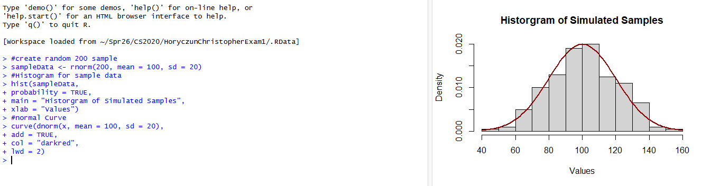
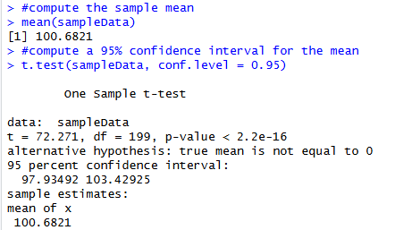
- From the simulated dataset, the sample mean came out to about 100.68, which is very close to the expected population mean of 100. Using t.test() in R, I calculated a 95% confidence interval for the mean, which ranges from 97.93 to 103.43. This interval represents the range of values where the true population mean is likely to fall. Since the original distribution had a mean of 100, it makes sense that the interval contains this value. Overall, this result shows that the simulated data behaves very similarly to the theoretical normal distribution we used to generate it.

Question 4:
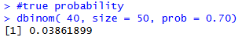
- I used the binomial distribution to calculate the probability that exactly 40 out of 50 users prefer the new interface. Since the company claims that 70% of users prefer it, the probability of success was set to 0.70. Using the dbinom() function in R gave a probability of about 0.0386. This means there is about a 3.86% chance of observing exactly 40 users preferring the interface if the company’s claim is correct.
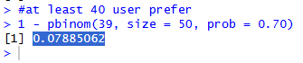
- I calculated the probability that at least 40 out of 50 users prefer the new interface. I used the pbinom() function to find the probability of 39 or fewer successes, then subtracted that value from 1 to get the probability of 40 or more. The result is about 0.07885, which means there is roughly a 7.9% chance of observing 40 or more users preferring the interface if the company’s 70% claim is correct. This outcome is somewhat unlikely but still possible under the given probability.
- I simulated 1000 surveys of 50 users using the rbinom() function in R. Each simulation assumes the probability that a user prefers the new interface is 70%. The histogram shows the distribution of the number of users who prefer the interface across the simulated surveys. Most of the values cluster around 35 users, which matches the expected value of np = 50 * 0.70 = 35. This simulation helps visualize what results we would typically expect to see if the company’s claim about the 70% preference rate is true.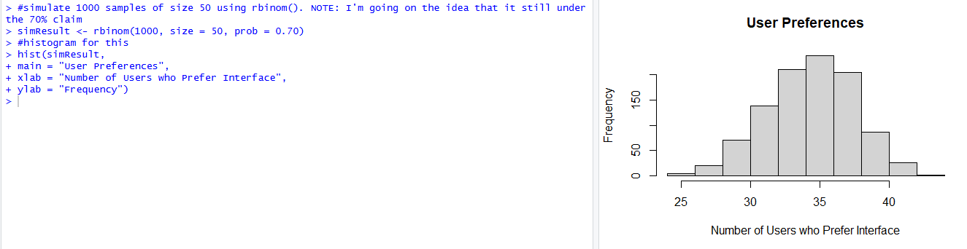
- The null hypothesis is $H_{0}:p=0.70$, which means the true proportion of users who prefer the new interface is 70%. The alternative hypothesis is $H_{1}:p≠0.70$, which means the true proportion is different from 70%. In the survey, 40 out of 50 users preferred the interface, which is a sample proportion of 0.80. Based on the simulated distribution, values around 35 were the most common, so 40 is higher than expected but still possible. Since the probability of getting 40 or more users was about 0.0789, this result seems somewhat unusual, but it is not rare enough to strongly reject the company’s claim. Overall, 40 out of 50 appears reasonably consistent with the 70% claim, although it is on the higher side of what we would expect.

